Appendix l: 3DPAWS Maintenance Manual

3D-PAWS MAINTENANCE MANUAL

INTRODUCTION
3D-PAWS is a cost-effective automatic weather station designed to measure:
- Rainfall
- Temperature
- Humidity
- Pressure
- Wind speed & direction
- UV
It uses 3D-printed structures integrated with sensors and a microcontroller for real-time data transmission.
Due to environmental exposure, regular maintenance is mandatory to ensure accuracy and reliability.
This manual provides detailed maintenance procedures for 3D-Printed Automatic Weather Stations (3D-PAWS). It is tailored to the actual hardware configuration including dual rain gauges, 3D-printed wind sensors, and modular PVC mounting systems.
The targeted user of this manual is the 3D PAWS site caretaker who should liaise with a 3D PAW technically competent person during the time of the system maintenance.

PREPARATION FOR THE MAINTENANCE
The field maintenance requires a few very basic tools as listed here below;
- A pliers
- Spirit level
- flat screw driver (A bout 5mm head)
- A star head screw driver (PH2 or PH3 size)
- Soft brush (Tooth brush will work better)
- Water (In a bucket)
Prepare a check list for all the work intended to be carried out like the example given here below;

Checklist sample
Component | Check | Status
Rain Gauge | Clean & tipping
Radiation Shield | Clean & airflow
Wind Sensors | Free rotation
Electronics | Dry & active
Solar Panel | Clean & charging
Structure | Stable & upright

Contact the 3 D PAWS Technician
When planning to carry out the routine maintenance, it is necessary to contact a 3 D PAWS technician a day before. The technician may offer necessary assistance especially in case of network issues.

SYSTEM COMPONENTS
- Dual Rain Gauge System (Funnel, Mesh, Tipping Bucket, Magnet)
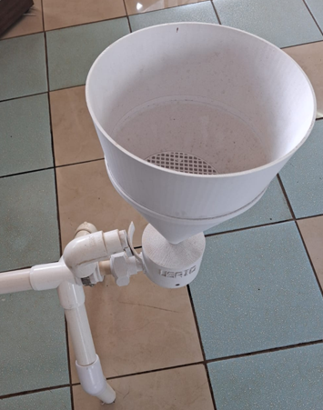
There are two such rain gauges per station
- Radiation Shield (Multi-plate, Temperature/Humidity Sensor)

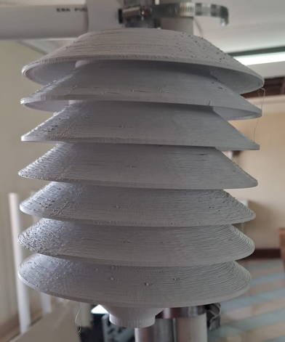

- Wind Sensors (3D-printed Anemometer and Vane)
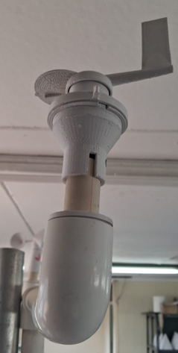
Wind direction sensor

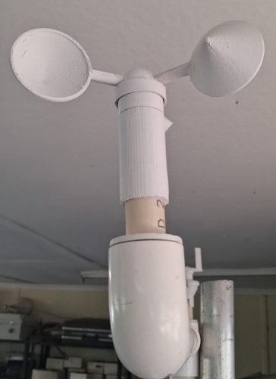
Wind speed sensor
- Electronics (Boron Logger, Battery, Wiring)
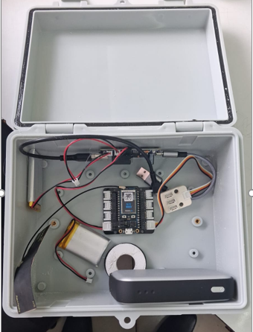
- Solar Power System
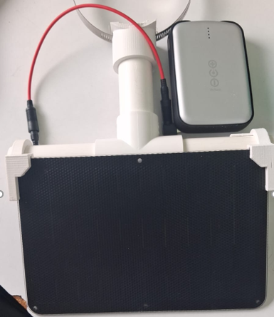
- Structural Frame (PVC + metal mast)

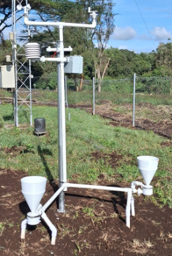

MAINTENANCE SCHEDULE
Activity | Frequency
Clean solar panel | Weekly
Clean rain gauge funnel & mesh | Weekly
Inspect tipping bucket | Monthly
Clean radiation shield | Monthly
Inspect electronics (moisture/insects) | Monthly
Check alignment & structure | Monthly
Grass cutting / site clearing | As needed

RAIN GAUGE MAINTENANCE (DETAILED)
Step 1: Remove mesh filter and rinse with clean water. Use a soft brush to remove debris.
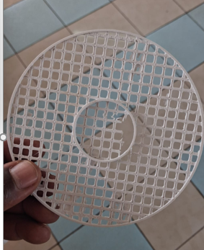
Mesh

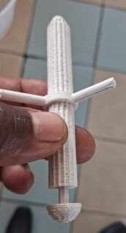
Filter

Step 2: Remove funnel gently by loosening clamp and bolt and lifting vertically
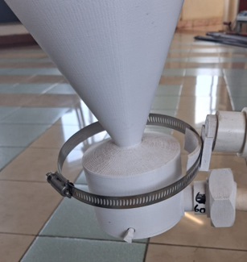
Bolt
Clamp
Step 3: Inspect funnel neck for blockage. Clear using water or thin rod.
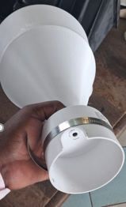
Make sure this hole is clean
Step 4: Open tipping bucket housing by removing clips on both sides.
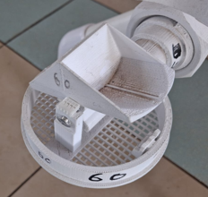
Clips

Step 5: Carefully remove tipping bucket without bending pivot.
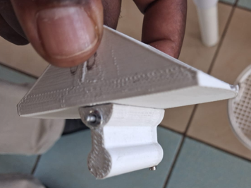
Pivot
Step 6: Clean bucket chambers and pivot axis. Ensure zero friction.
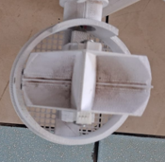
Buckets
Step 7: Inspect magnet at the back of the bucket (Report if missing or highly corroded)
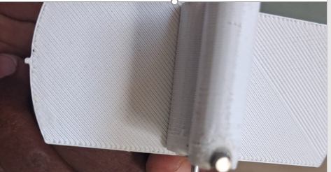
Magnet
Step 8: Reinstall bucket ensuring correct alignment with sensor.
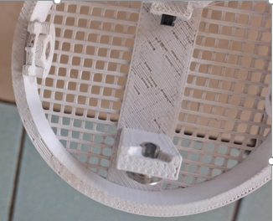
Sensor

Step 9: Reassemble housing and funnel while making sure that the base is level by use of a spirit level provided.
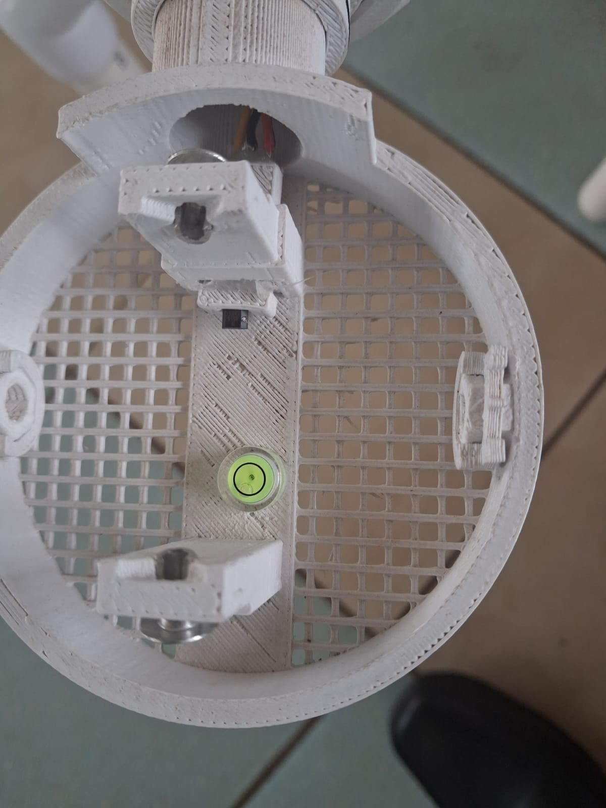
Spirit level
Step 10: Perform test by pouring water slowly and confirming consistent tipping.
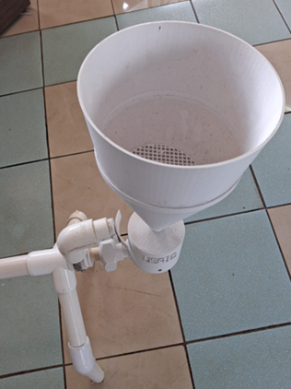
Pour water here to test the tipping

RADIATION SHIELD MAINTENANCE
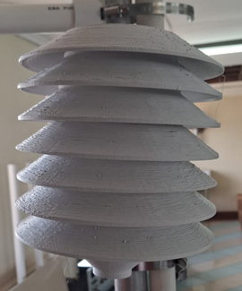
Step 1: Inspect for dust accumulation between plates.
Step 2: Use cloth or compressed air to clean.
Step 3: Check for insect nests and remove.
Step 4: Ensure plates are evenly spaced and not warped.

WIND SENSOR MAINTENANCE
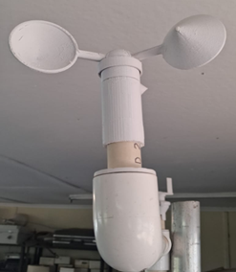
Step 1: Manually spin cups; verify free rotation.
Step 2: Inspect for cracks or imbalance.
Step 3: Check vane movement and alignment.
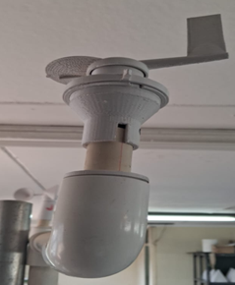
Step 4: Inspect shaft for friction; clean if necessary.
Step 5: Tighten mounting connections.

ELECTRONICS MAINTENANCE
Step 1: Open data logger enclosure box carefully to avoid falling parts which are not fitted on the enclosure case.
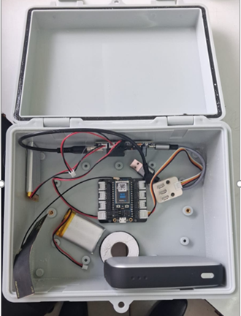
Data logger battery
Data logger
Main battery connected to the solar panel
Gasket (Prevent water and dust from getting in)
Step 2: Remove insects and debris.
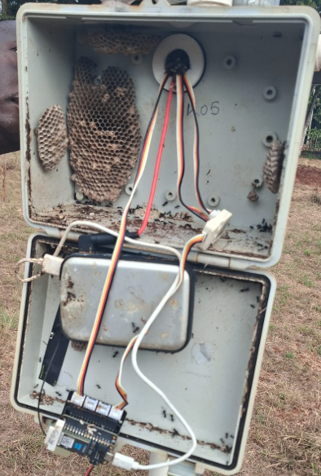
Heavy buildup of insects
Step 3: Check battery condition and wiring.
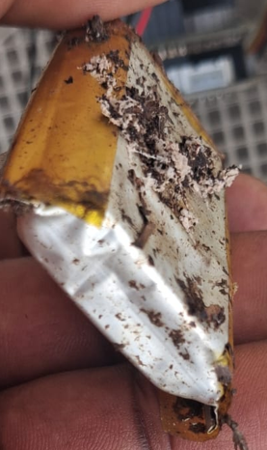
Insects affected data logger battery
Step 4: Ensure enclosure is dry. Check the gasket (rubber around the closing point of the data logger box. Either the gasket is poorly closed or worn out
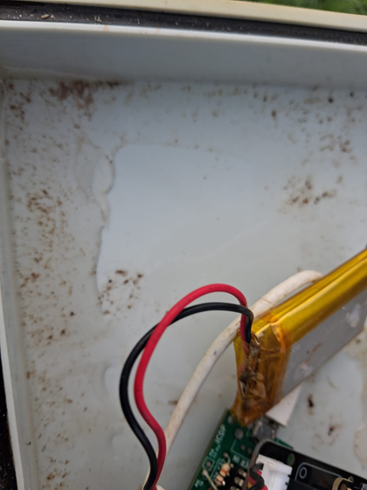
Water that has found its way into the data logger box through the gasket
Gasket
Step 5: Check if there is any light on the Boron data logger. If there is no light, this may mean that the battery is bad
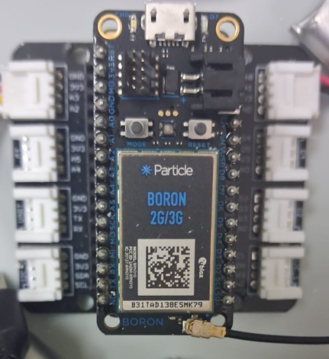
If the Boron data logger is healthy, there should be a blue flickering light here
Step 6: Report any faulty components.

FIELD CHECKLIST
After everything is done, fill the check list appropriately as indicated below. File the check list for future reference.
Component | Check | Status | Comments
Rain Gauge | Clean & tipping | Ok | The base was out of level but leveled
Radiation Shield | Clean & airflow | Ok
Wind Sensors | Free rotation | OK
Electronics | Dry & active | Ok
Solar Panel | Clean & charging | Ok
Structure | Stable & upright | Ok

TROUBLESHOOTING LOGIC

RAIN FAILURE:
Check funnel → Clean → Test
If still faulty → Check bucket movement
If stuck → Clean pivot
If not → Either the magnet or faulty wiring (Report the issue)

WIND FAILURE:
Check rotation → If stuck → Clean
If free → Check cable
If OK → Report the issue

SYSTEM OFFLINE:
Check battery → Report if dead
Check solar → Clean panel
Check connectivity → Report

DESIGN-SPECIFIC NOTES
Due to 3D-printed components, periodic inspection for wear, cracks, and UV degradation is essential. Dual rain gauge systems require calibration comparison to detect faults.

